**Project Name: Share The Meal**

**Project Member:**

**Satyajeet Yadav 220343120095**

**Anmol jadhav 220343120013**

**Aniket Patil 220343120012**

**Shrikant Patange 220343120069**

**Abstract:**

Food wastage is a massive problem and one of the most overlooked things in today’s world. One third of all food produced in the world goes to waste.

Some restaurants/cafés have a policy to not serve food from previous day, despite being perfectly edible. This is all thrown away as “waste”, at the end of day. At the same time, worldwide most of people do not have enough to eat. That means one in nine people are suffering from hunger. Also many street animals haven`t get food minimum one time in a day.

Our project provides a way to bridge the gap between the wastage and deficit, by letting restaurants donate this food to needy like food community, animal care organizations, Food processing units etc.

**Implementation Technologies:**

1. **Spring Boot:**

Spring Boot is an open source Java-based framework used to create a micro Service. It is developed by Pivotal Team and is used to build stand-alone and production ready spring applications.

**1.1 Features of Spring Framework:**

## 1. Web Development

It is well suited Spring module for web application development. We can easily create a self-contained HTTP server using embedded Tomcat, Jetty or Undertow. We can use the spring-boot- starter-web module to start and running application quickly.

**2.Spring Application**

It is a class which provides the convenient way to bootstrap a spring application which can be started from main method. You can call start your application just by calling a static run() method.

**3.Admin Support**

Spring Boot provides the facility to enable admin related features for the application. It is used to access and manage application remotely. We can enable it by simply using spring.application.admin.enabled property.

**4.Externalized Configuration**

Spring Boot allows us to externalize our configuration so that we can work with the same application in different environments. Application use YAML files to externalize configuration.

**5.Security**

Spring Boot applications are spring bases web applications. So, it is secure by default with basic authentication on all HTTP endpoints. A rich set of Endpoints are available for develop a secure Spring Boot application.

**2.** **MySQL**

MySQL, the most popular Open Source SQL database management system, is developed, distributed, and supported by Oracle Corporation.

**Features of MySQL:**

* **MySQL is a database management system.**

A database is a structured collection of data. It may be anything from a simple shopping list to a picture gallery or the vast amounts of information in a corporate network. To add, access, and process data stored in a computer database, you need a database management system such as MySQL Server. Since computers are very good at handling large amounts of data, database management systems play a central role in computing, as standalone utilities, or as parts of other applications.

* **MySQL databases are relational.**

A relational database stores data in separate tables rather than putting all the data in one big storeroom. The database structures are organized into physical files optimized for speed. The logical model, with objects such as databases, tables, views, rows, and columns, offers a flexible programming environment.

* **MySQL software is Open Source.**

Open Source means that it is possible for anyone to use and modify the software. Anybody can download the MySQL software from the Internet and use it without paying anything.

* **The MySQL Database Server is very fast, reliable, scalable, and easy to use.**

MySQL Server was originally developed to handle large databases much faster than existing solutions and has been successfully used in highly demanding production environments for several years. Although under constant development, MySQL Server today offers a rich and useful set of functions. Its connectivity, speed, and security make MySQL Server highly suited for accessing databases on the Internet.

* **MySQL Server works in client/server or embedded systems.**

The MySQL Database Software is a client/server system that consists of a multithreaded SQL server that supports different back ends, several different client programs and libraries, administrative tools, and a wide range of application programming interfaces (APIs).

**3.React**

The React. js framework is an open-source JavaScript framework and library developed by Facebook. It's used for building interactive user interfaces and web applications quickly and efficiently with significantly less code than you would with vanilla JavaScript.

**Hardware and Software Requirements (Minimum):**

**Hardware:**

1. Intel i3 processor 3rd generation or later / AMD Ryzen 200 2nd generation or later

2. 2 GB ddr3 ram.

3. Windows 7 Home edition or later.

4. 200 GB Sata HDD Space

5. Data Connection 200 kbps

**Software:**

1. Eclipse 4.7 Oxygen
2. MySQL 5.7 with Workbench 8.0
3. Google Chrome version 79.0
4. STS
5. Visual Studio Code
6. **ER Diagram:**

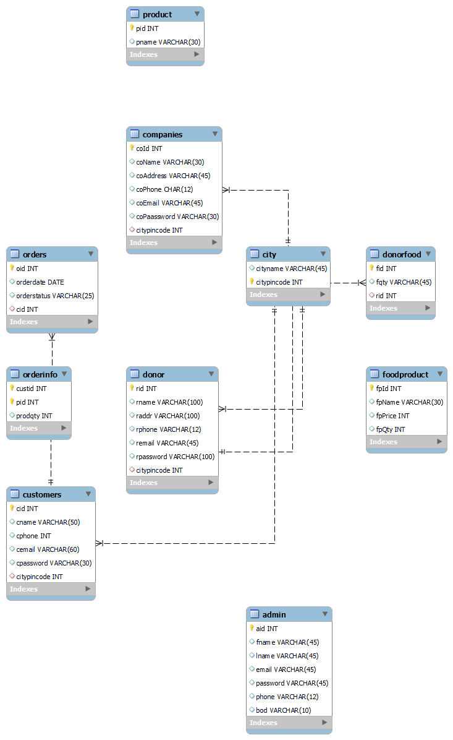

1. **Table Structures:**
2. **Table name:** **companies**

-------------+-------------+------+-----+---------+----------------+

| Field | Type | Null | Key | Default | Extra |

+-------------+-------------+------+-----+---------+----------------+

| coId | int | NO | PRI | NULL | auto_increment |

| coName | varchar(30) | YES | | NULL | |

| coAddress | varchar(45) | YES | | NULL | |

| coPhone | char(12) | YES | | NULL | |

| coEmail | varchar(45) | YES | | NULL | |

| coPaassword | varchar(30) | YES | | NULL | |

| cityPincode | int | YES | MUL | NULL | |

+-------------+-------------+------+-----+---------+----------------+

1. **Table name:** **foodproduct**

+---------+-------------+------+-----+---------+----------------+

| Field | Type | Null | Key | Default | Extra |

+---------+-------------+------+-----+---------+----------------+

| fpId | int | NO | PRI | NULL | auto_increment |

| fpName | varchar(30) | YES | | NULL | |

| fpPrice | int | YES | | NULL | |

| fpQty | int | YES | | NULL | |

+---------+-------------+------+-----+---------+----------------+

1. **Table name:** **city**

**+-------------+-------------+------+-----+---------+-------+**

**| Field | Type | Null | Key | Default | Extra |**

**+-------------+-------------+------+-----+---------+-------+**

**| cityName | varchar(30) | YES | | NULL | |**

**| citypincode | int | NO | PRI | NULL | |**

**+-------------+-------------+------+-----+---------+-------+**

1. **UML Diagrams:**

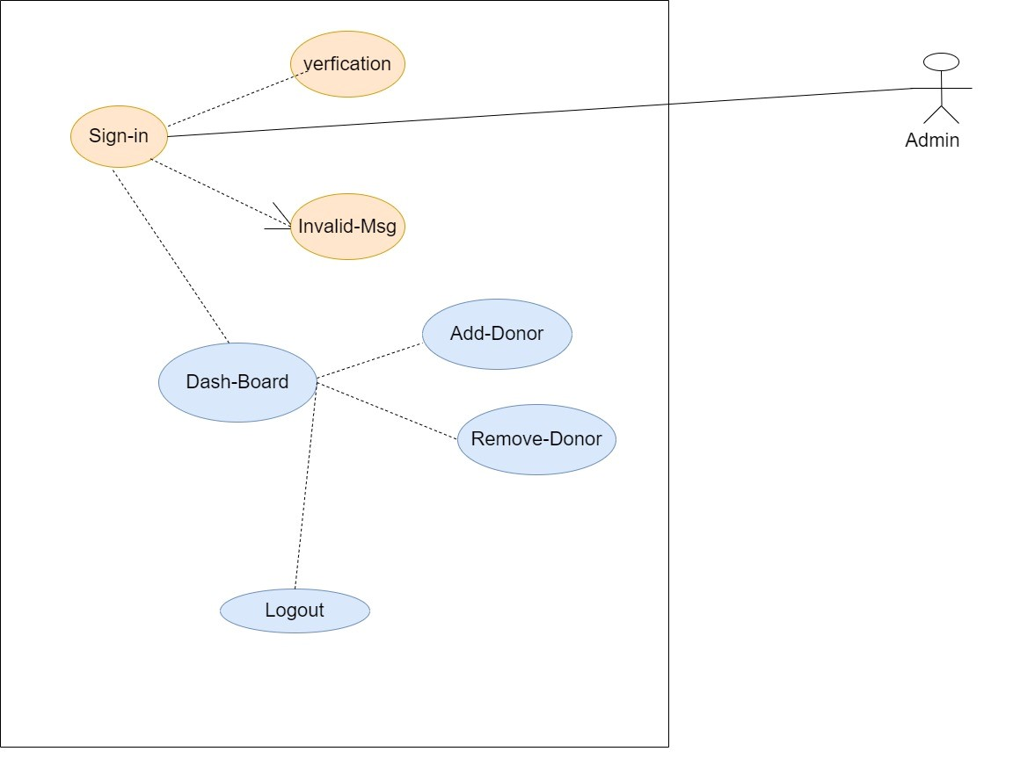

Figure 1:

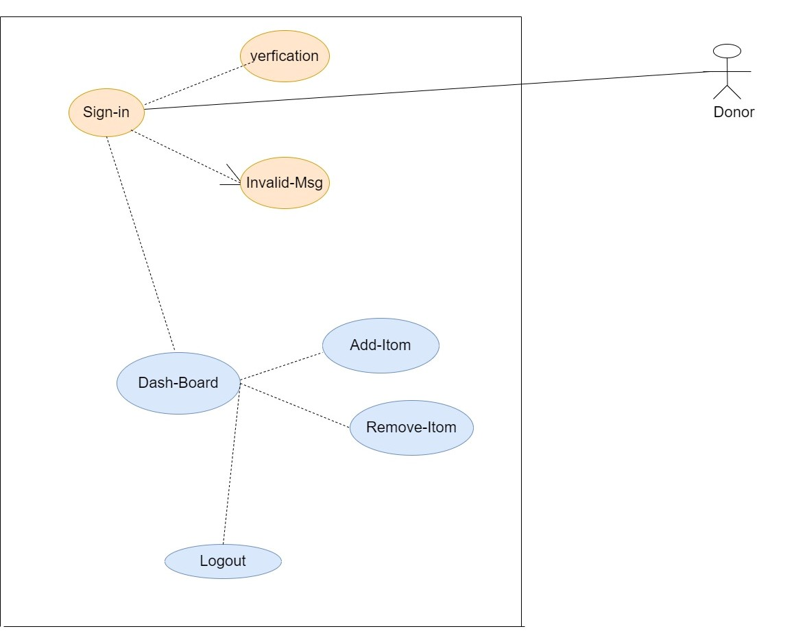

Figure 2:

1. **End to End Flow of Application:**

**User:**

* 1. User will login to the portal or will have to register if he is not a registered user.
  2. After registration User will login and Dashboard page will be displayed to him which will display view products, view profile and log out.
  3. From that page can User can click on the ‘**view products’** button and reach the products which are displayed by companies .
  4. After ‘Log Out’ it will open home page .

**Donor:**

1. Donor will login to the portal or will have to register if he is not a registered user.
2. After registration donor will login and dashboard page will be displayed to him which will display add food ,view profile and log out .
3. After ‘Log Out’ it will open home page.

**Company:**

* 1. Company will login to the portal or will have to register if he is not a registered user
  2. After registration company will login and dashboard page will be displayed to him which will display add products,view products and log out.
  3. After ‘Log Out’ it will open home page.

1. Future Scope of Project
2. Improvement in design.
3. Mobile Application
4. Online Payment Option

**Thank You!**